**Name – Joshoua Simon**

**Class – LYIT (Core)**

**Enrollment Number – MITU20BTIT0030**

**Roll No – 2205011**

GOOGLE CLOUD APP ENGINE:-

Google App Engine is a Platform as a Service (PaaS) offering by Google Cloud that allows developers to build, deploy, and scale applications easily without having to manage the underlying infrastructure. It is designed to provide a simple and scalable way to host web applications and APIs, handling tasks such as automatic scaling, load balancing, and server maintenance.

Yaml code-

runtime: python

api_version: false

handlers:

  - url: /.*

    script: app.py

App .py code-

print(“HELLO”)

GCLOUD COMMANDS-

C:\Users\simon\AppData\Local\Google\Cloud SDK>google-cloud-sdk\bin\dev_appserver.py "C:\Users\simon\OneDrive\Desktop\GAE"

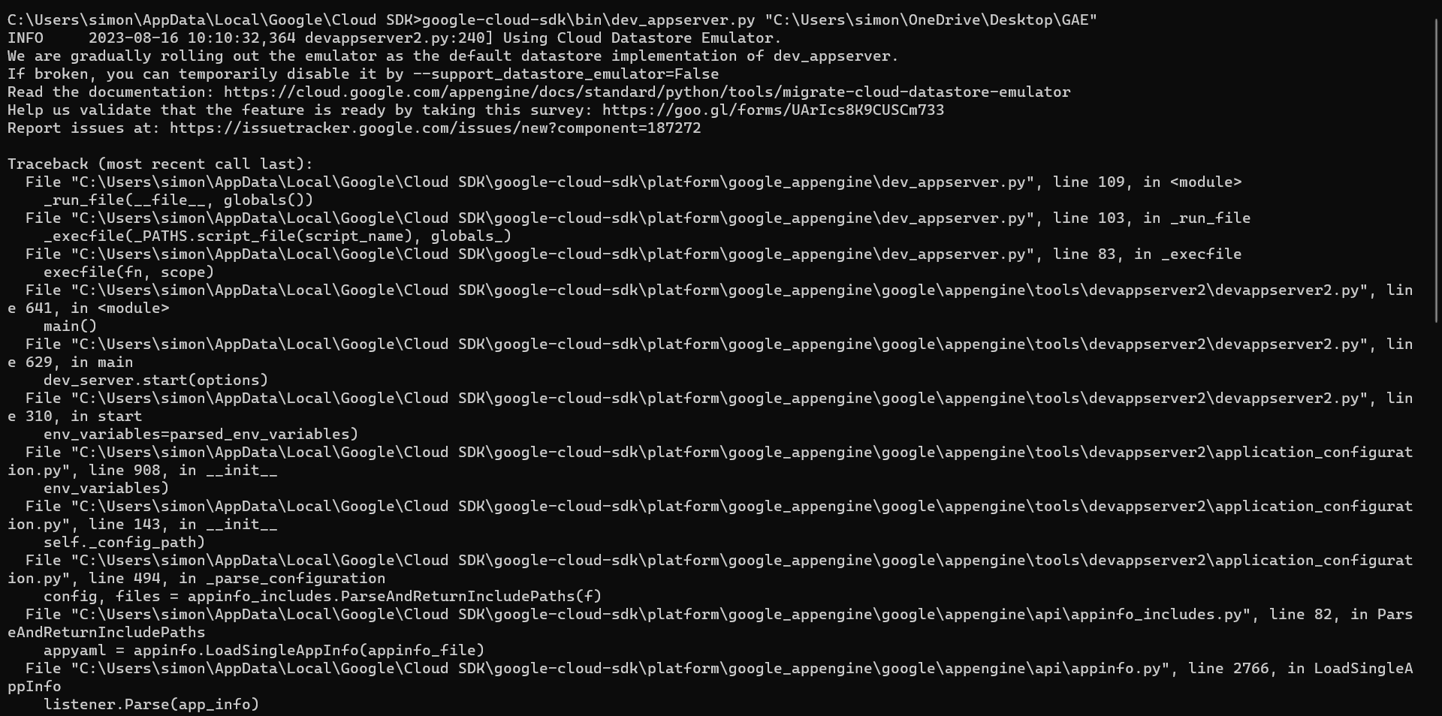

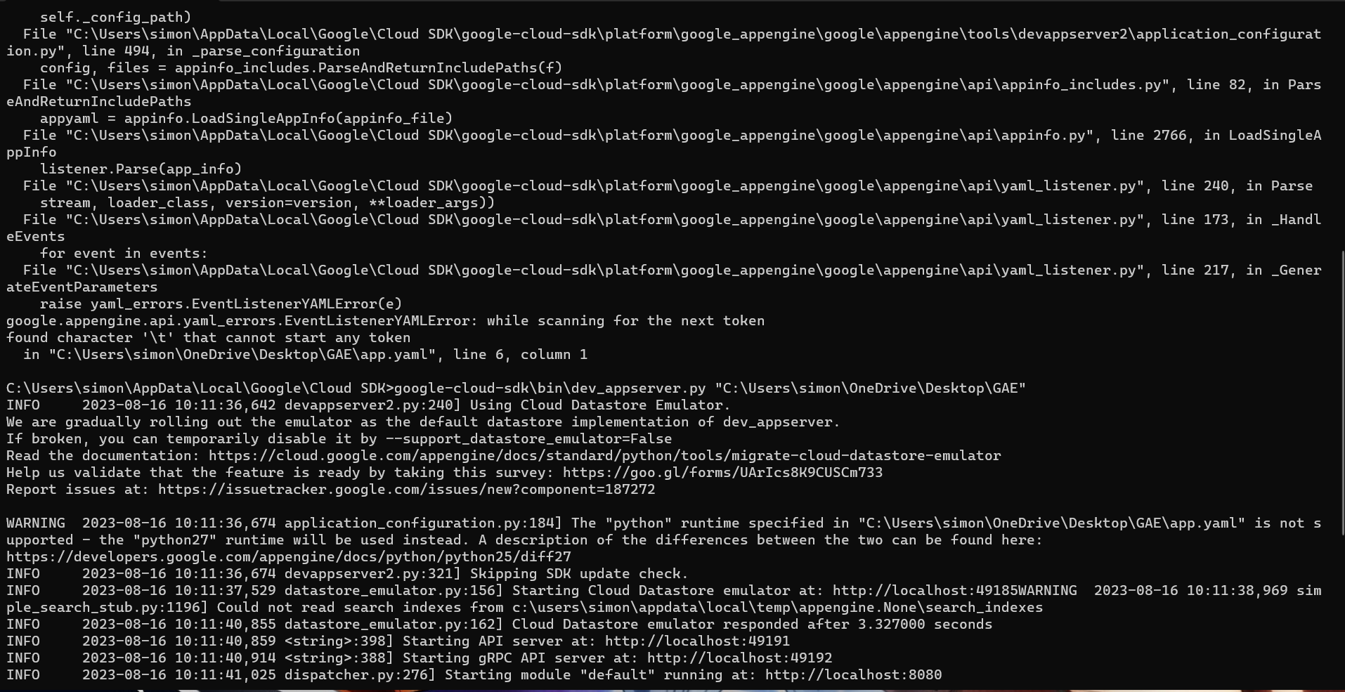

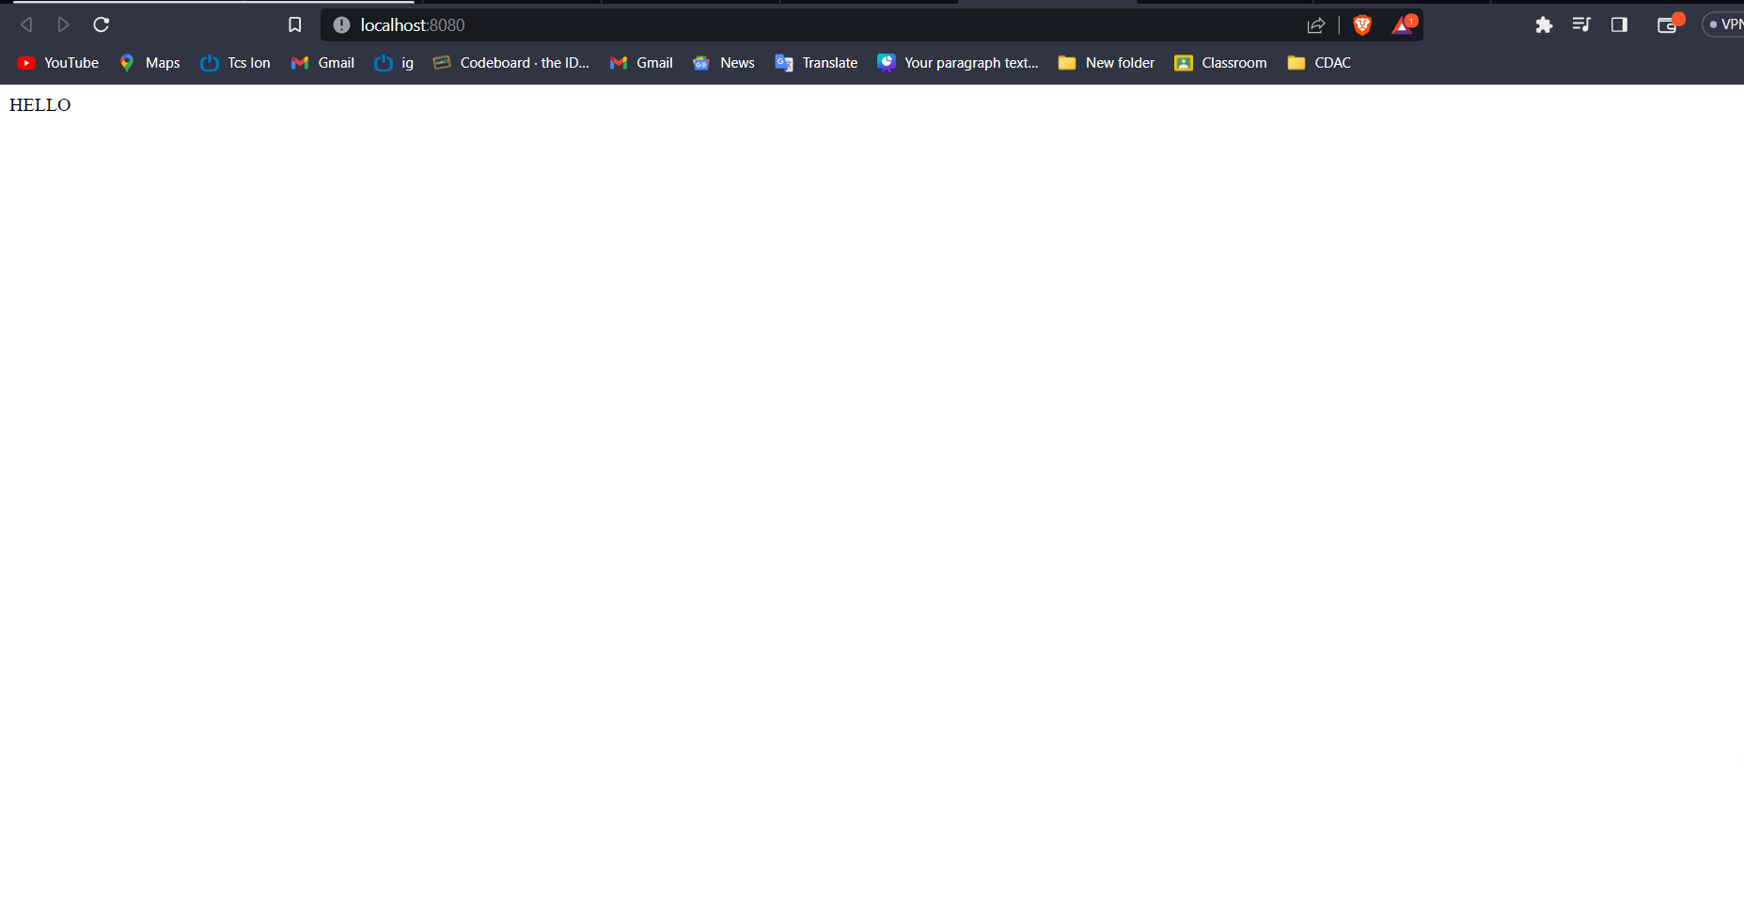

## STEPS-

**Install Google Cloud SDK:**

If you haven't already, you'll need to install the Google Cloud SDK on your local machine. This SDK provides the command-line tools and libraries required to interact with Google Cloud services.

You can download and install the SDK from the official Google Cloud website.

**Authenticate with Google Cloud:**

After installing the SDK, you'll need to authenticate yourself to access your Google Cloud resources. Run the following command and follow the prompts to log in:

**gcloud auth login**

**Create a Project:**

If you haven't created a Google Cloud project for your website, you'll need to do so. You can create a project using the following command:

**gcloud projects create PROJECT_ID**

Set Project Configuration:

Set your default project configuration using the project ID you've just created:

**gcloud config set project PROJECT_ID**

Enable App Engine:

If you're planning to use Google App Engine to host your website, you'll need to enable it for your project:

**gcloud app create**

Deploy Your Website:

Use the following command to deploy your website to Google App Engine. Replace YOUR_APP_NAME with a suitable name for your app and PATH_TO_WEBSITE_FILES with the local path to your website's files.

**gcloud app deploy --project=PROJECT_ID --version=VERSION_ID PATH_TO_WEBSITE_FILES**

Access Your Website:

Once the deployment is successful, you'll receive a URL where your website is accessible. You can also open the URL using the following command:

**gcloud app browse**